CAMPUS LOST & FOUND BOARD
@CREATIVITY THINK (9483175986/7019689991)

ABSTRACT:
Campus Lost & Found Board is a dynamic web application designed to help students, staff, and visitors report lost or found items within campuses such as colleges, universities, offices, and hostels. Users can upload photos, specify locations, add timestamps, and submit claim requests with proof. The system supports safe interactions through moderated posts, duplicate detection, chat-based meetup coordination, and item resolution tracking. Admins can verify reports, flag suspicious entries, merge duplicates, and analyze trends through a dashboard powered by Recharts. Built using Django REST Framework and React, the platform provides a centralized, efficient, and transparent way to recover lost belongings..

INTRODUCTION OF THE PROJECT:
Every campus faces the recurring issue of misplacing items such as ID cards, books, gadgets, bags, and accessories. Traditional notice boards or WhatsApp groups are ineffective and unorganized, often resulting in unclaimed items or unresolved cases.
The Campus Lost & Found Board creates a structured digital solution that allows users to report lost or found items, upload images, search posts, coordinate meetups, and finalize claims. Administrators can monitor all entries, prevent misuse, identify common loss zones, and maintain historical records. This system improves campus safety, reduces confusion, and enhances the chances of recovering lost items..

PROJECT OBJECTIVES:

• Provide a centralized portal for posting lost or found items
• Allow users to upload images, location tags, and timestamps
• Enable users to send claim requests with identification proof
• Support chat communication for meetup coordination
• Track status updates until item resolution
• Allow admins to moderate posts and verify authenticity
• Merge duplicate or repeated reports efficiently
• Provide analytics on most common locations and lost items
• Maintain complete item history and monthly summaries

PROBLEM OF THE STATEMENT:
Campuses often deal with multiple lost and found cases, but lack a structured digital system for tracking and resolving them. Manual methods lead to confusion, repeated posts, or fraudulent claims. Without analytics, the administration cannot identify hotspots where items are frequently misplaced.
This project solves these issues by offering a moderated, searchable, and analytics-driven platform that streamlines every step—from reporting an item to resolving a claim..

MOTIVATION OF THE PROJECT:
• To provide a reliable and organized system for managing lost and found cases in campuses
• To prevent misuse through moderation and verification
• To support faster item recovery using photos, location tagging, and chat communication
• To identify trend patterns through analytics such as common item types and frequently affected areas
• To enhance campus security and user satisfaction
• To digitize and modernize the traditional lost-and-found process

BLOCK DAIGRAM OF PROJECT:

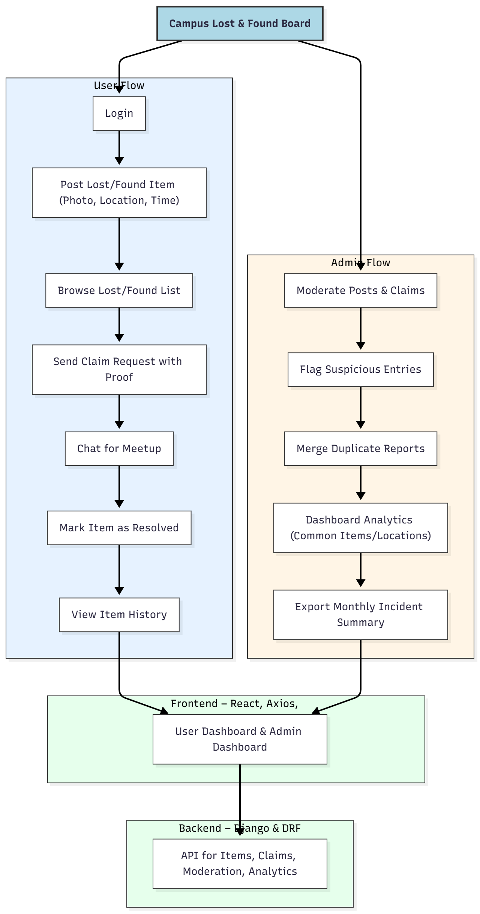

WORKING OF THE PROJECT:
Users first log in to the system and submit a lost or found post by adding the item name, description, photo, campus location, and timestamp. Other users can browse the list, filter by category or location, and send claim requests by submitting proof such as ID cards or matching item details.
A chat option allows both parties to coordinate a safe meetup. Once the item is verified and handed over, the user can mark it as resolved, creating a permanent entry in their history log.
Admins oversee all posts, approve or reject entries, and flag suspicious or repeated submissions. Duplicate detection helps avoid multiple listings for the same item.
The dashboard provides analytics on frequently lost items and locations, helping administrators improve campus safety and awareness. Monthly summaries can be exported for official reporting..

SOFTWARE REQUIREMENT:
- Backend:
  - Python 3.x
  - Django
  - Django REST Framework
  - SQLite/PostgreSQL
- Frontend:
  - Node.js and npm
  - React.js
  - Axios
- Development Tools:
  - Visual Studio Code
  - Postman (for testing APIs)
  - Git/GitHub (for version control)
- Server/Deployment (Optional):
  - Gunicorn, Nginx, or Heroku/AWS for hosting

ADVANTAGES OF THE PROJECT:

• Quick and structured lost–found reporting system
• High chances of item recovery due to photos, location tags, and chat
• Prevents fraud through admin moderation and verification
• Duplicate detection reduces confusion
• Dashboard analytics improve campus safety planning
• Easy to use for both students and administrative staff
• Maintains complete history for transparency

APPLICATIONS OF THE PROJECT:
• Colleges and universities
• Office campuses
• Public institutions
• Hostels and dormitories
• Corporate campuses
• Large residential blocks

REFERENCES:

- Django REST Framework Documentation — Django Software Foundation. Django Documentation. Available: https://docs.djangoproject.com/
- Django REST Framework. DRF Documentation. Available: https://www.django-rest-framework.org/
- React. React Official Documentation. Available: https://reactjs.org/docs/getting-started.html
- Redux. Redux Documentation. Available: https://redux.js.org/introduction/getting-started
- PostgreSQL Global Development Group. PostgreSQL Documentation. Available: https://www.postgresql.org/docs/
- MySQL. MySQL Reference Manual. Available: https://dev.mysql.com/doc/
- Git. Git Documentation. Available: https://git-scm.com/doc
- Node.js. Node.js Documentation. Available: https://nodejs.org/en/docs/
- Axios. Axios Documentation. Available: https://axios-http.com/docs/intro
- Socket.io Documentation – https://socket.io/docs/

